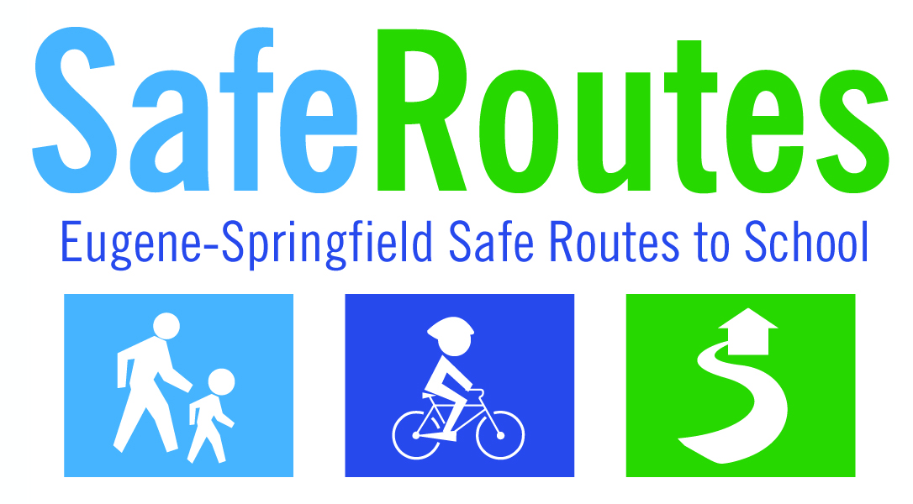
Walk+Roll to School Day Classroom Tracking

Teacher Name:____________________________________________

Grade:___________

Room Number:___________

Number of Students in Class Today:___________

We want to count how students got to school today. Please ask your students which ONE mode of transport they took to school today. They can count walking if they parked more than a couple blocks away and walked in. Please count the students and then turn this sheet into the office. Thanks!

___________ Walked

___________ Biked

___________ Skated, Scootered, or otherwise rolled by human power

___________ Rode the School Bus

___________ Took a Car or Carpool

